Naomi Almero
Enhancement Two: Algorithms and Data Structure
The artifact I selected for the Algorithms and Data Structures category is my Python-based Stray Text Adventure Game, originally created early in my computer science coursework. The initial version of the game used basic Python dictionaries to store rooms and items, simple lists for inventory, and relied on repetitive string comparisons for command handling. While functional, the program lacked structure, efficiency, and algorithmic depth. Operations such as navigation, item lookup, and command parsing were handled through linear searches and nested conditionals, making the code harder to maintain and scale. The original implementation also did not include any pathfinding logic, limiting the ability to efficiently determine the shortest route between rooms.
For the enhancement, I redesigned the program’s internal data handling by creating a Room class to store each room’s name, connections, and contained item, replacing the earlier dictionary-of-dictionaries approach. I also implemented a CommandParser class to process all player inputs, replacing if-else string checks with structured parsing logic. Inventory management was refactored into a dedicated list with clear functions for adding and removing items. A major improvement was adding a breadth-first search (BFS) algorithm to allow the player to find the shortest path between rooms, demonstrating the use of graph-based data structures. This enhancement demonstrates the use of graph traversal, queues, and visited-node tracking to avoid cycles. These changes made the game more modular, improved computational efficiency for lookups and navigation, and allowed for easier extension and maintenance of code.
Reflecting on the process, I learned how even a small console-based game relies on thoughtful algorithm and data structure design. Moving to object-oriented components for rooms and commands improved clarity and made the project easier to maintain. Implementing BFS required analyzing the room connections as a graph and managing paths efficiently using a queue. One challenge I encountered was integrating the new pathfinding logic with the existing movement system while ensuring that invalid inputs or unreachable rooms were handled gracefully. Overcoming this required careful testing and refactoring earlier assumptions about how rooms were linked. Overall, this enhancement strengthened the game both technically and structurally, and it allowed me to demonstrate stronger proficiency in algorithms, graph traversal, class design, and data management.
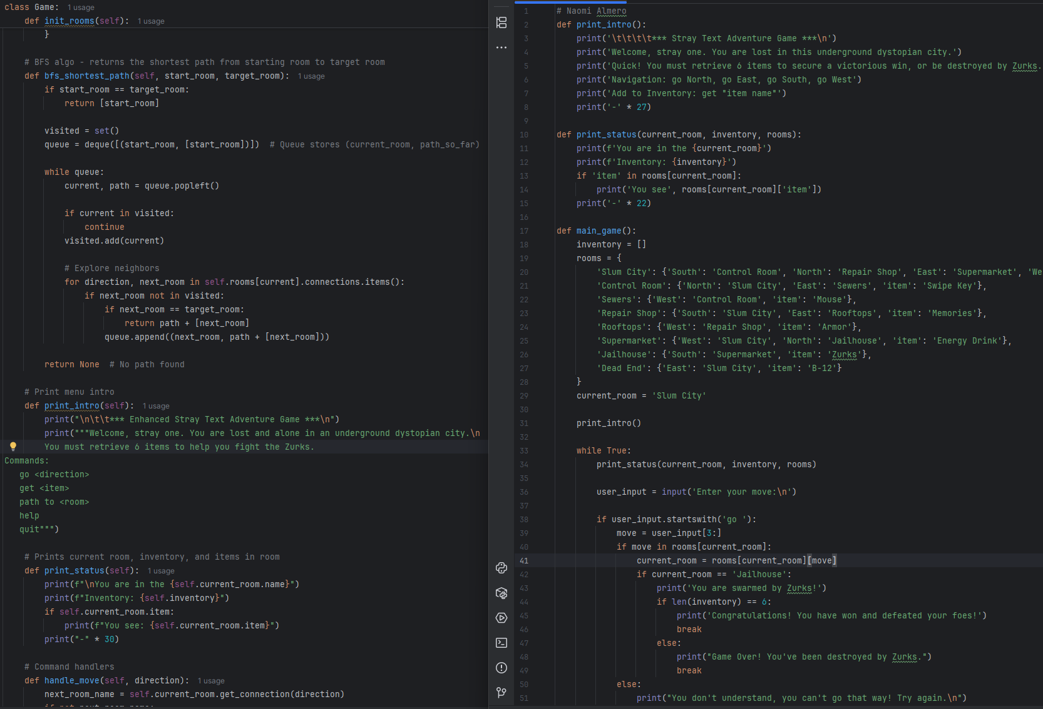
This demonstrates the BFS algorithm to compute the shortest path between rooms. It uses a queue and a visited set to efficiently traverse rooms while avoiding cycles, ensuring optimal path discovery. This enhances functionality while showcasing practical application of queue-based data structures.

